B1E Havo/VWO Onderwerp: Breuken vermenigvuldigen

1  $$\frac{3}{4}⋅\frac{1}{3}$$ | 2  $$2\frac{1}{6}⋅4\frac{3}{7}$$ | 3  $$\frac{1}{2}+\frac{4}{6}⋅\frac{2}{5}$$ | 4  $$1\frac{1}{6}⋅3\frac{1}{2}$$ | 5  $$\frac{1}{2}⋅\frac{14}{15}$$ | 6  $$22⋅1\frac{1}{7}$$
7  $$\frac{1}{10}⋅-\frac{4}{7}$$ | 8  $$\frac{1}{5}-\frac{1}{6}⋅\frac{2}{10}$$ | 9  $$(\frac{3}{4}+\frac{1}{6} )⋅1\frac{1}{2}$$ | 10  $$\frac{1}{2}⋅\frac{4}{6}⋅\frac{2}{5}$$ | 11  $$\frac{3}{5}⋅2⋅\frac{5}{12}$$ | 12  $$\frac{3}{7}⋅\frac{6}{9}$$
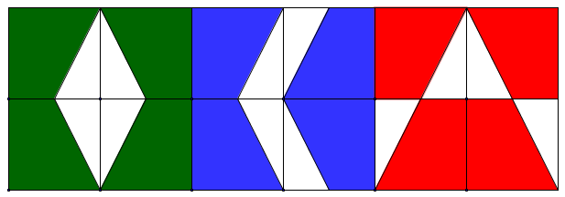

1  $$-\frac{2}{35}$$ | 2  $$\frac{2}{15}$$ | 3  $$\frac{1}{9}$$ | 4  $$9\frac{25}{42}$$ | 5  $$\frac{1}{2}$$ | 6  $$\frac{7}{15}$$
7  $$4\frac{1}{12}$$ | 8  $$\frac{1}{4}$$ | 9  $$25\frac{1}{7}$$ | 10  $$\frac{1}{6}$$ | 11  $$\frac{23}{30}$$ | 12  $$4\frac{1}{8}$$

